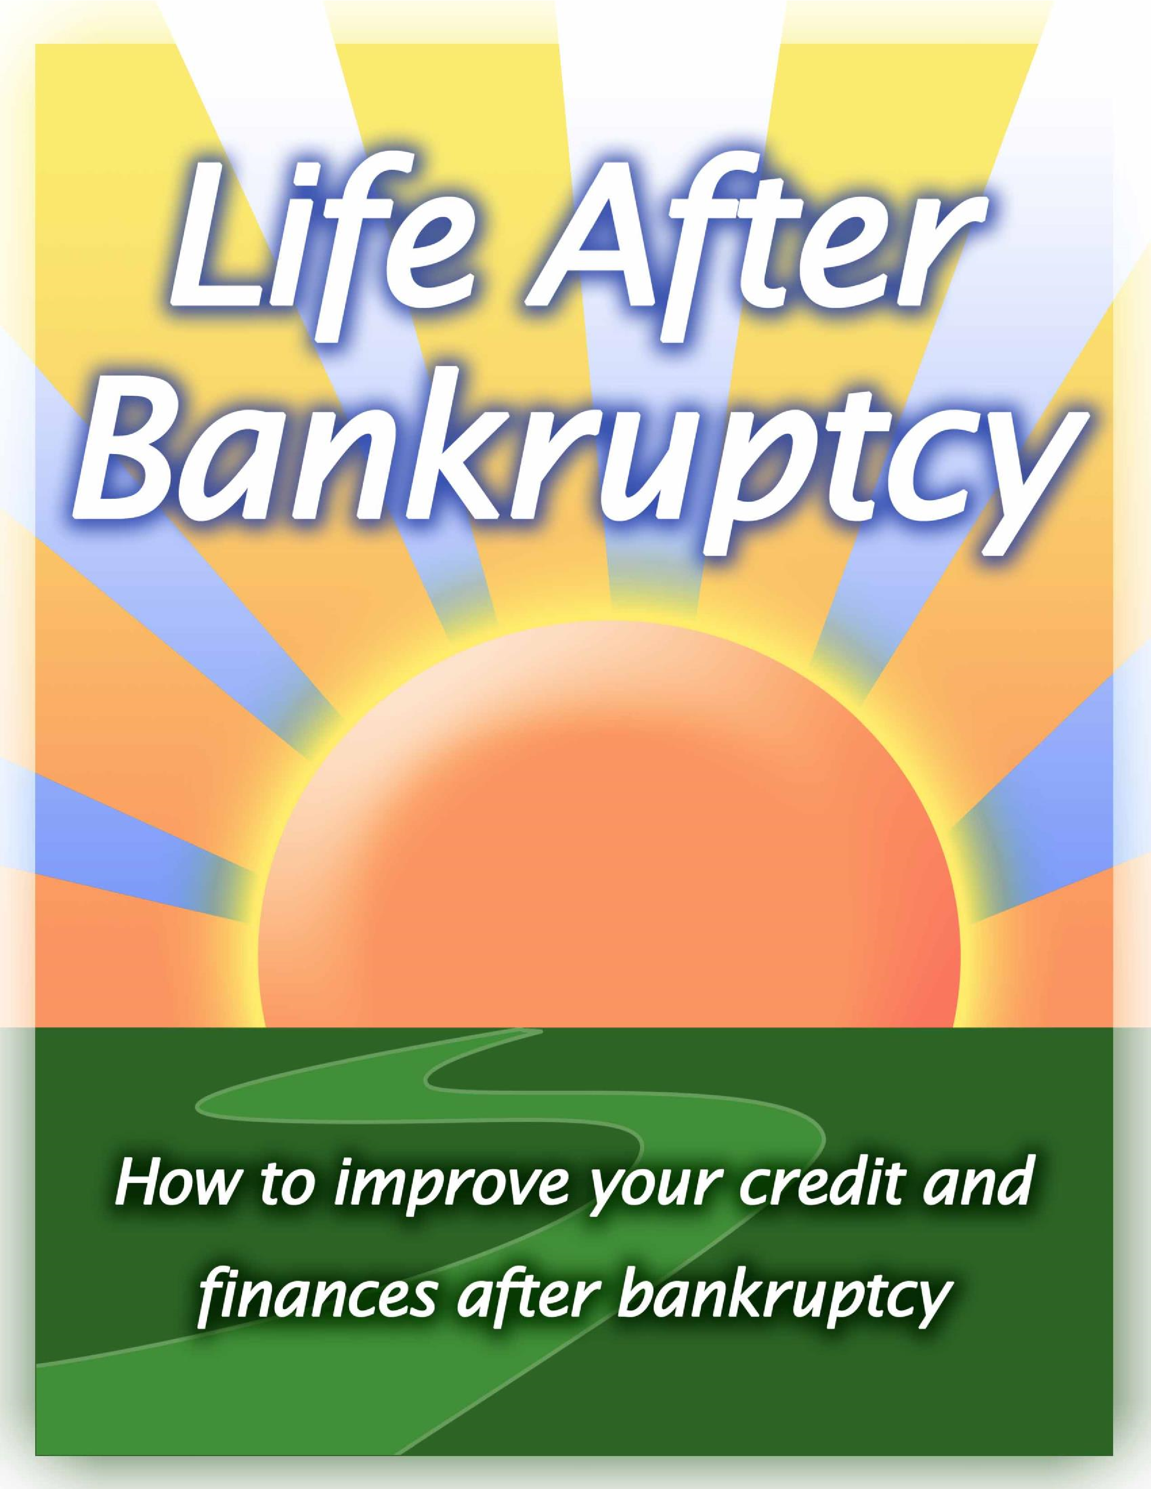

Introduction
Bankruptcy can be a financial lifesaver. However, while
filing bankruptcy eliminates most or all of your debts and “You must gain control over your takes huge stress away, it usually doesn’t completely solve money or the lack of it will forever
your financial challenges. Many people struggle to make control you.”
effective financial decisions after filing bankruptcy, which -Dave Ramsey, Financial Author brings continued stress and frustration and sometimes the need to file bankruptcy again years later.
The good news is that there are many things you can do to improve your finances and credit score after bankruptcy. Within a few years, you can rebuild and improve your financial situation and have a more fulfilling future.
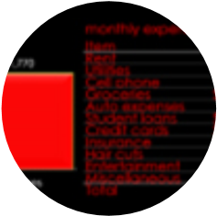
This Ebook gives some advice on how to:
Debt
Finances
Credit
- Avoid and manage various types of debt
- Budget and manage your finances effectively
- Rebuild and improve your credit
Part 1: How to Avoid and Manage Debt
While bankruptcy eliminates most types of debt, it
doesn’t eliminate all of them, nor does it prevent you from incurring future debts. To avoid these burdens, you should consistently strive to 1) Eliminate any remaining debts you may have that aren’t discharged by bankruptcy and 2) Avoid unnecessary debts.

Eliminating Any Remaining Debt
If bankruptcy eliminates all of your debts, great! If Student Loan Debt not, your top priority should be to pay off any
“Even if you were to fall into extreme
remaining debts that you may have, such as student financial hardship and file for bankruptcy,
loans, unpaid taxes, and child support.
you need to understand that your student
Here are some tips for paying off debts: loan debt will not be discharged in
bankruptcy. It is the Velcro of all debts.” • Be aggressive in paying off your debts. The -Suze Orman, Personal Financial Guru faster you pay them off, the sooner you’ll have peace of mind
- Track how much debt you have with a spreadsheet, on paper, or with free software tools like Mint.com
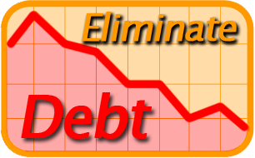
- If you have multiple debt sources, start by paying off the highest interest rate debts first or by paying off the smallest balance first
- Take a second job (temporarily) or work more hours at your current job to create extra income to pay off your debts
- Cut your living expenses, eliminate luxury items, and live frugally to create extra income to pay off debts
- Delay purchases on items that aren’t immediate needs
- Automate debt payments to ensure that you are paying off your debts consistently
- Involve others in helping you stay motivated and accountable in your debt-reduction goals
- Consider negotiating with your creditors (Ex: the IRS) to settle your debts

Avoiding Debt
In addition to paying off any remaining debts, you should avoid adding additional debt.
The Dangers of Debt Interest
There are 3 general types of debt: emergency debts, “Interest never sleeps nor sickens nor spending debts, and investment debts. Each type of dies; it never goes to the hospital; it debt has different strategies you can use to manage works on Sundays and holidays; it
them effectively. never takes a vacation…it has no love,
Emergency Debts no sympathy; it is as hard and soulless
Emergency debts are unexpected and often occur as a granite cliff. Once in debt, interest from misfortunes or from immediate needs, such as: is your companion every minute of the day and night; you cannot shun it or
- Medical/dental expenses slip away from it; you cannot dismiss
- Unemployment/Underemployment it; it yields neither to entreaties,
- Divorce demands, or orders; and whenever you
- Family death get in its way or cross its course or fail
- Natural disasters to meet its demands, it crushes you.”
- Injury/Accidents

-J. Reuben Clark, U.S. Ambassador
While you can’t completely control whether or not these things happen, you can take precautionary measures to avoid them or reduce their negative impact if they happen.
You can reduce or eliminate your risk against these types of debt by doing the following:
- Medical/dental debt: Buy good health and dental insurance, eat healthy food, and exercise regularly. This reduces your chances of needing costly medical procedures.
- Family death: Buy quality life insurance that will meet your income needs and funeral costs should a family member pass away.
- Injury/Accidents: Buy auto and disability insurance to reduce any medical bills that you may have from car wrecks or work accidents.
- Divorce/Unemployment/Underemployment: Save up to 6-8 months of living expenses in a bank account to use in case you lose your job or get a divorce.
- Natural disasters: If your area is prone to disasters such as hurricanes, tornadoes, or floods, buy supplemental disaster insurance and home insurance to protect yourself financially.
Spending Debts You are 100% in control of how you spend your money.
Needs and Wants
However, many people get into financial trouble by not paying
close enough attention to their spending habits or by not “We buy things we don't need showing self-control. with money we don't have to
impress people we don't like.”
Spending debts are most often incurred through: -Dave Ramsey, Financial Author
- Car loans or leases
- Shopping purchases on electronics, jewelry, video games, etc.
- Excessive credit card use
Spending debts can be reduced or eliminated entirely by following these tips:
- Focus on your needs, not your wants
- Save up for large purchases instead of buying on credit
- Avoid impulse purchases on material items like clothing, gadgets, restaurants, travel, etc.
- Limit the amount of credit cards you use to 2-3
- Pay with cash or debit cards to avoid overusing credit cards
- Avoid payday and short-term loans to avoid paying high interest rates
- Buy a car that is within your means
- Live in a home or apartment with a mortgage or rent payment that is well within your means

Investment Debts
Home Mortgages
Student Loans
Business Loans
These types of debts help you improve your income potential and standard of living. They
come in 3 main flavors:
- Home mortgages
- Student loans
- Business loans
These types of debts are not necessarily bad, but need to be used with caution and wisdom. Consider these strategies to manage investment debts effectively:
- Home mortgages: Just because you qualify for a certain value of home doesn’t mean you should buy it. Keep your home mortgage reasonable and live within your means.
- Student loans: Carefully determine what career goals you have and what type of skills and education is needed to help you achieve them. If formal education is required, consider attending an affordable university, community college, tech school, or online university. Try saving up for college, working during school, or spreading out classes over a longer period of time to avoid taking out as many (if any) student loans.
- Business loans: All aspiring entrepreneurs should carefully assess their business skills, create a business plan, and analyze potential risks and rewards of their business endeavor before seeking business loans. Alternatively, you can obtain funding without accruing debt by seeking equity funding from angel investors.

Summary
By paying off any remaining debts that you have after bankruptcy, avoiding all unnecessary debts, and wisely choosing investment debts, you will avoid overextending yourself into debt and filing bankruptcy again.
Part 2: How to Budget and Manage Finances

Effectively
Managing finances can often times feel like a burden that we easily set out-of-sight, out-of-mind. However, by taking control of your finances with effective habits and practices, you will have more financial freedom and a more fulfilling life.
From great books and online articles from financial experts to budgeting software and apps, there are plenty of resources that you can use to manage your finances efficiently.
Here are some tips for managing your finances effectively:

1. Show Self-Control and Restraint
Effective financial management is mainly a matter of self-control. If you can develop the attitude of using your money wisely, finances become easy to manage.
Money Management
“If money management isn't something you enjoy, consider my perspective. I look at managing my money as if it were a part-time job. The time you spend monitoring your finances will pay off. You can make real money by cutting expenses and earning more interest on savings and investments. I'd challenge you to find a part-time job where you could potentially earn as much money for just an hour or two of your time.” -Laura D. Adams, Financial Expert

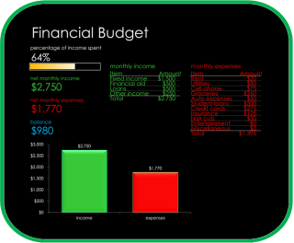
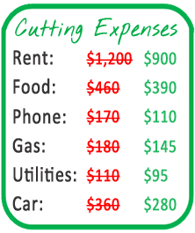
Determining what things in your life are necessities (utilities,
2
. Make a
Written Budget

Having a written budget,
whether on paper, a
spreadsheet, or software

t
ool,
can help
you stay disciplined
and
track your financial
progress.
You should set goals
and keep record of your
income, expenses,
discretionary income, and
savings.

Pay attention to
spending on charitable
donations,

f
ood, rent, utilities,
phone
(
s), tv,
cable, gas,
insurance, vehicle
maintenance, home maintenan
ce,
clothing, debt payments, dates, vacations, and medical expenses.
As you stick to your budget, you will avoid wasted spending,
avoid debt, and meet your financial goals.

Allocate

planning
time
to periodically

set goals, track progress,
and find ways to improve your financial management.

To assist you with your budgeting, you can use a free Microsoft
Excel budgeting template,
free online resources like Mint.com, or
plenty of other free tools and apps available online.

3
.
Minimize
or

E
liminate
E
xpenses

food, clothing) and what items are luxuries (eating at restaurants, cable TV, etc) will help you find ways to save.
As you find ways to spend less, you will free up funds to be used towards more important things. For example, you may sell your fancy car and buy a used one, move to a more modest home, eat at home instead of at restaurants, use coupons and wait for sales, or buy more affordable clothing. Every dollar saved adds up and gives you more financial freedom.

4. Increase your income
After you are using your income as efficiently as possible, you can try and find ways to increase your income by working towards a pay raise, working additional hours, or finding a better-paying job.
To make yourself more valuable in the workforce, seek out skills (Ex: web design, home repair), knowledge (Ex: Spanish, accounting), and formal education (Ex: nursing degree). Set aside time when you aren’t working to learn from Internet resources and websites, online classes, night classes, and internships. The more you know and the more skills you have, the more you can raise your income. 5. Save for Purchases and Tough Times
Importance of Education
“I am concerned that too many people are focused too much on money and not on their greatest wealth, which is their education.” -Robert Kiyosaki, Financial Author
Saving helps you prepare for potentially difficult times and to avoid using credit for purchases. While it requires patience to save, saving can help you avoid many financial troubles.
Saving helps you prepare for unexpected expenses (Ex: your car breaks down), unemployment, and unexpected opportunities (Ex: invest in a new business). Should bad times come, without sufficient savings you will be forced into overusing credit cards and loans to survive.
Also, saving allows you to spend less on items that you want to purchase. Appliances, cars, and even homes cost less in the long run if you have money saved up to pay entirely with cash or pay a large down payment. The money you save by not having to pay as much interest makes saving worth the effort.
6. Invest Your Money
Saving money will only create wealth for you if you invest it wisely. Once your money is being spent as efficiently as
“An investment in knowledge pays the best interest.” -Benjamin Franklin

possible, it is time to make your money work for you. Instead of paying interest, you can get paid interest by investing in various opportunities.
Investments are primarily long-term tools, meaning they are fit for saving for retirement, children’s educations, or starting a business.

Importance of Investing
“How many millionaires do you know who have become wealthy by investing in savings accounts? I rest my case.” -Robert G. Allen,

Businessman

Use the Internet to research various investment strategies (such as bonds, stocks, mutual funds, etc) and choose the investments that will help you reach your goals. You will find satisfaction watching your money grow and compound automatically over time through successful investments.

Summary
You can’t predict or control the financial challenges that life brings. However, as you wisely manage your finances, you can avoid many financial problems and be more prepared when unexpected financial difficulties arise.

Part 3: Rebuild and Improve Your Credit
Once you’ve got a firm grasp on your debts and your finances, you should also consider how to improve your credit score, which is a measurement of your credit history and trustworthiness to current and potential lenders. Since bankruptcy negatively affects your credit score for up to 7-10 years, it takes active effort on your part to improve your credit history and score.
Why should you care about how good your credit score is? The higher your credit score, the more trustworthy and responsible lenders see you. This means you will be more likely to qualify for loans on homes, vehicles, education, businesses at lower interest rates.
Here are some tips for how to improve your credit history and habits to increase your credit score:
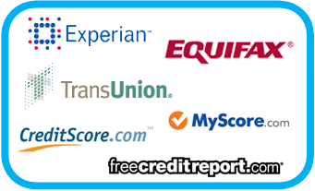
1. Monitor and track your credit score First, you need to know what your credit score is to know how much improvement you need to make. You can look it up 2-3 times a year through free credit report sources like Equifax, Experian, or TransUnion. Credit scores range from around 300-900. Generally, a score of 619 and below is considered poor, a score of 720 and above is seen as excellent, while in between 619-720 is considered fair to good.
Your credit score is measured based on the timeliness of your payments, the amount of debt in relation to the amount of credit you have, the length of your credit history, the type of credit you have, and the amount of credit recently obtained, and amount of recent searches for credit.
As you work to improve your credit history, you should periodically track your credit score to see the impact of your financial decisions on your credit.

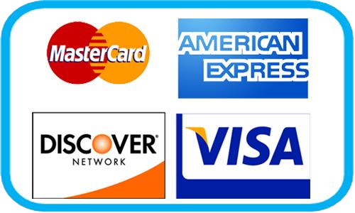
2. Apply for credit
After bankruptcy, you likely won’t qualify for many loans, such as mortgages, car loans, or business loans. The best place to start applying for credit is through a credit card. If you don’t qualify for a standard credit card, try applying for a secured credit card or a store card (Ex: Home Depot, Wal Mart, etc).

Don’t apply too frequently for credit, as this will hurt your credit score. If you are rejected from a credit application, pay attention to the reasons the lender gives you for why you were rejected. 3. Manage credit wisely
Once you have a credit card, use it wisely over time to improve your credit score. Here are some tips for managing credit wisely:
- Only spend on things you can afford
- Make every payment on time and schedule automatic payments if possible to avoid paying late.
- Pay more than the minimum payment each month, and ideally try and pay off the entire balance
- If you can’t pay off the entire balance, keep the balance as low as possible
- Avoid having too many credit cards and keeping a high balance on cards that you do have • Ideally, use less than 30% of your max credit limit to avoid harming your score • Keep cards active for long periods of time to improve your credit history. 4. Enjoy the fruits of good credit
Over time, your credit history will improve as you maintain healthy amounts of credit and successfully make payments over time. As a result, when you apply for credit for vehicles, homes, businesses, and education, you will be more likely to qualify and receive lower interest rates. Your credit limit will raise as well.

Summary
Rebuilding your credit history and credit score takes time and patience. However, as your credit score begins to grow, you will enjoy lower interest rates on loans and qualify for car, home, student, and business loans that you wouldn’t have qualified for before. By wisely applying for and using credit over time, your score will increase and your financial outlook will improve.

Conclusion
Bankruptcy is a great first step towards eliminating most or all of your debt. However, you should actively take steps towards improving your credit and finances to fully restore your financial stability.
By avoiding and managing debt, budgeting and managing finances efficiently, and rebuilding your credit, you will create a strong financial foundation that will help you avoid bankruptcy in the future and live a more fulfilling life.
Need More Help?
We hope that you have enjoyed this Ebook! For a Free Consultation about 1) filing bankruptcy please call Firebaugh & Andrews for a Free Consultation 734-722-2999

