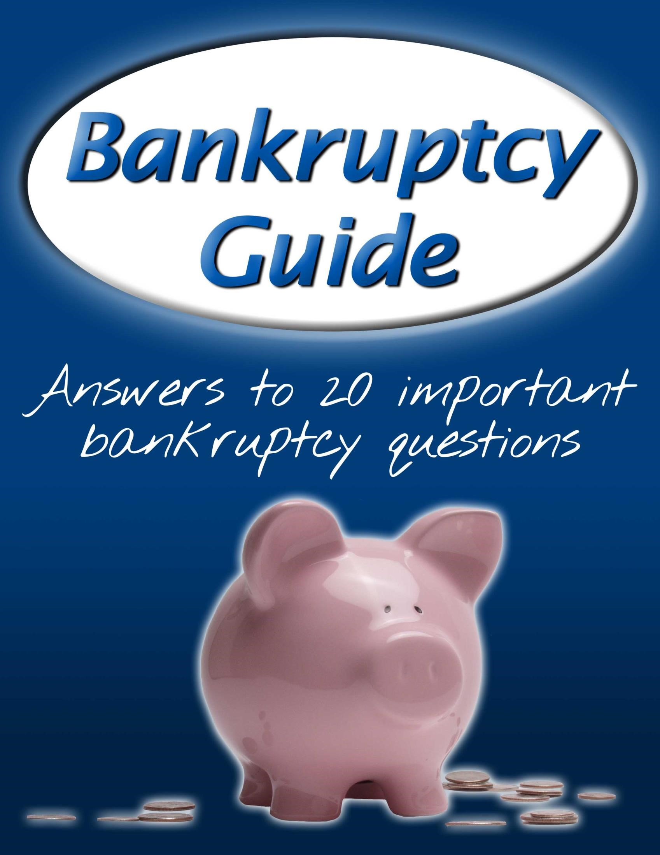

Bankruptcy Guide for
Beginners

Answers to 20 common

bankruptcy

questions

We hope you find this guide useful and informative. We
look forward to helping you eliminate debt
and get a
fresh financial start.

1
. How do attorneys help with bankruptcy and what
qualities should I look
for in an attorney?

Bankruptcy
can be

a simple process, but understanding

how to complete the steps
efficiently

and
properly
takes experience and legal knowledge. While it is

possible to file bankruptcy without an attorney,

having an attorney gives you many benefits, such as:

1.

You
avoid making filing m
istakes

that lead to

having your case rejected

2.

You get help
choosing the type of bankruptcy

that will most help you eliminate or

restructure debt.

3.

You
avoid the stress

of making sure each step

is done properly. An attorney will walk you

thro
ugh each step.

As you decide on an attorney to help you, consider the following:

•

Personality
:
Is the attorney easy to talk to, friendly, and helpful? Does the
attorney sincerely care about your situation?

•

Experience
Does the attorney have years of experie
:
nce with bankruptcy? Does
the attorney have a successful record of helping
clients

file successfully?

•

Education
:
Did the attorney graduate from a reputable law school? Is the
attorney knowledgeable about bankruptcy?

2 . What is bankruptcy and who is it for?
Bankruptcy is the process where individuals and businesses can eliminate or restructure most or all of their debts in a legally prescribed manner. The goal of bankruptcy is to help individuals get a fresh financial start and recover from burdensome debts.
Bankruptcy can help you to eliminate your debts completely, eliminate some of your debts, or help you create a payment plan for your debts that is more manageable.
Bankruptcy is for any individual or business who seeks relief from excessive debts.
- What are the qualifications or requirements for bankruptcy?
Generally, the law allows anyone to file for bankruptcy. However, the requirements for each type of bankruptcy vary. You may qualify for one of the following types of bankruptcy.
  - Chapter 7: Usually, to qualify for Chapter 7, you must pass the means test, which means that your 6-month average monthly income prior to your filing date must be below the state median income (varies state-by-state). If you don’t pass the means test, it is likely that you will need to file for Chapter 13 instead of Chapter 7.
  - Chapter 13: To qualify for Chapter 13, you don’t need to pass the means test. Rather, you need to have enough discretionary income beyond your allowed living expenses to be able to pay a portion of your debt. You must have an income source for the next 3-5 years to be able to do so.

- What benefits come from filing bankruptcy?

There are several benefits that come from filing bankruptcy, such as:
Automatic Stay: When you file bankruptcy, you are protected with a court order from creditors, who are legally prevented from pursuing you for debt collections.
Eliminate Debt: With Chapter 7, you can eliminate all eligible debt. While there are some types of debt that are not eligible for elimination, you can get rid of most or all debts.
Keep Your Assets: Many times you can keep your home, vehicles, and other property.
Restructure Debts: With Chapter 13, you can make

manageable debt payments for 3-5 years. This lowers your debt burden dramatically.
Peace of Mind: You have much more control over your creditors.
Fresh Start: You have a fresh financial start.
5. What are the steps in the bankruptcy process?

The bankruptcy process is fairly simple and straightforward. You will follow these steps, which will vary based on whether you file Chapter 7 or Chapter 13.
Attorney Consultation: Before you submit your filing papers to the court, you should meet with an attorney to discuss your options, see if you qualify for Chapter 7 or Chapter 13, and choose the best solution to eliminate your debt. Choose a Type: You will choose between Chapter 7 or Chapter 13
Credit Counseling: You can complete this 2-3 hour class online, on the phone, or in person. You will get a certificate when you complete it.
Gather Necessary Documents: You will need proof of any income, your last two years of tax returns, and bank account information.
File Your Case: You will fill out paperwork regarding your income, assets, expenses, and debts. You will state if you are filing for Chapter 7 or Chapter 13.
Automatic Stay: Once you file your papers (Chapter 7 or Chapter 13), the court will notify your creditors of your filing. They will be legally prevented from pursuing you for debt collections, garnishments, and liens.
341 Meeting: For Chapter 7 and Chapter 13 cases, you will meet with your attorney, trustee, and sometimes creditors in a nearby courthouse to discuss your income, expenses, assets, and debts to ensure that they are accurate.

Liquidation (Ch.7 only): If you qualify for Chapter 7, in some circumstances your trustee may sell your non-exempt assets and take the proceeds to pay your creditors.
Confirmation Hearing (Ch.13 only): If your income and circumstances qualify you for Chapter 13, your attorney will meet with a judge, a trustee, and possibly your creditors to review your proposed repayment plan. They will review, revise (if necessary), and approve it.
Debtor Finance Class: You will complete a class that is similar to the one you took prior to filing bankruptcy. This class is 2-3 hours long and discusses various principles of finance, debt, and budgeting.
Debt Eliminated/Paid Off: With Chapter 7, your eligible debts are completely eliminated after 3-4 months. With Chapter 13, you keep your assets and make monthly payments on your debts until you have completed your 3-5 year plan.
After that, any remaining eligible debt is eliminated.
Finished: You’re free from debt!
6. Who is involved in my bankruptcy case?

Unlike a traditional court case that has a jury, judge, and many others, there are very few people involved with your bankruptcy case. Other than yourself and spouse (if filing together), here are the people involved in your case:
Your Attorney: He or she will advise you, help you complete the necessary steps to file, and make sure that your case goes smoothly and successfully.
Your Creditors: These may be representatives from credit card companies, banks, car companies, and any other individual or company to whom you owe money. They attend a creditors’ meeting (if they choose to come) to review your case with your attorney and/or the trustee.
Judge: A judge is appointed to preside over your case. The judge’s involvement is limited in most cases unless there are disputes or contested matters
Trustee: Appointed by the Office of the U.S. Trustee, this person
is in charge of administering your case, presiding over the
creditors’ meeting, handling liquidation procedures in Chapter 7 cases, and continually monitoring your Chapter 13 payment
plan. The trustee is paid a portion of the court fees, the Chapter 7 liquidation payments (if any), and the Chapter 13 repayments.

8. What types of bankruptcy are there?
The three most common types of bankruptcy are Chapter 7, 11, and 13. Each one has its own unique benefits.
- Chapter 7: In this type of bankruptcy, you eliminate all or most of your debt in 3-4 months. Generally, you must pass the means test to qualify and may have to turn over some assets as well.
- Chapter 13: In this type of bankruptcy, you keep your assets (home, vehicle, etc) and create a 3-5 year payment plan for your debts. If your income is higher than the median state income or if you need to protect an asset, this may be your best option for eliminating or reducing your debt burden.

7
.
Where do I go for my bankruptcy case
?

You won’t have to travel much to file bankruptcy.
And unlike

typical court cases,
bankruptcy cases
often
don’t involve
appearing before a
judge. You can complete
many

steps (including filling out the necessary paperwork) from your home.

Your Attorney’s
Office:

It is best to meet with your
attorney
at his or her office

to discuss your situation,
get advice, and make a plan to eliminate debt.

The Courthouse

or Trustee’s Office
:
With
Chapter 7 and Chapter 13 cases, you will meet with
your attorney and
so
metimes
creditors in a nearby
courthouse (not the court
room

itself, but in the same
building)
to trustee’s office
to discuss your assets,
income, and debts.
Often with

Chapter 13 cases, you
will
also
appear
in

court to have a judge and creditors
review you
r payment plan and approve or revise it.

- Chapter 11: This type is intended for businesses or individuals with a very large amount of debt that have a high probability of future profitability and needs to restructure debts to stay afloat. It can also be used for individuals in some circumstances.
We can evaluate your situation and help you see which types you qualify for and help you choose the one that will benefit you the most.

. How long does the bankruptcy process take?
9

The time it takes to eliminate your debt and get a fresh start varies based on the type of
bankruptcy that you file.

Chapter 7

:

Takes
an average

of 3
-
4
months,

depending

on how complex the case is.

Chapter 13
:

Takes
an average

of 3
-
5
years

depending on
the terms of
your payment plan

that you
create.

Chapter 11
:

Reorganization plans average

5
years
.

10
. How much does bankruptcy cost?

There are three main costs associated with

filing bankruptcy
:

Court Fees
:
The court charges a filing fee that is required

by law. For a Chapter 7 case, the fee is $338, for a

Chapter 13 case the fee is $313 and for a Chapter 11 case

the fee is $1738.

Trustee

Fees
:

T
he trustee receive
x

a portion of the court fee, a portion of the
Chapter 7 liquidation sales, and a portion of the Chapter 13 payments.

Attorney Services
:
The rates for attorney services vary based on where you
live, how complex your case is, and w
hat kind of bankruptcy you are filing. For
a Chapter 7 case, the national average is around $
1,250
. Chapter 13 cases
average
around $4,000

nationwide due to their more complex nature
.
Chapter
11
cases are the most expensive and vary dramatically based on
each situation.

. What debts are erased through bankruptcy?
11

Most types of debt
can

be erased through bankruptcy. A few examples are:

Medical bills

Credit card debt

Vehicle loans

Personal loans

Business
debts

Leases

Secured debt (debt that is

associated with property that

can be repossessed)

Older tax debt

Debts that
cannot

be erased through bankruptcy:

Child support and alimony

Newer

tax
debt

Debts for personal injury or death to

others caused by drunk driving
, etc

Fines and penalties for violating laws

Student loans

12
. What happens to my assets during bankruptcy?

Assets are things of value that you own, such as a home, car, jewelry, etc. What
happens
to your assets depends on the t
ype of bankruptcy that you file, and the exemptions you
are allowed to use to protect your assets.

With Chapter 7
You
:

list out all of your assets and mark
those that you feel are exempt
the trustee’s control
.
C
redito
rs
or trustee
s

can object to your exemptions. If no one objects,
then the property is considered exempt and cannot be
taken
.
Each state has its own standards on how much property can
be counted as exempt. Usually, a portion of your home and
vehicle are con
sidered exempt, as well as household goods
and furnishings and retirement assets.

With Chapter 13
Generally, y
:
ou don’t have to worry about
losing assets since you are paying
some or all of your

debts in
a 3
-
5
year plan. There is

no liquidation with Chapt
er 13.

13
. What is credit counseling and how does it help?

Those
filing

bankruptcy must take a mandatory credit counseling
class
. Provided by
various organizat
ions, it usually costs around $3
, takes an
0

hour or two

to complete, and
can be taken over t
he phone, through the internet, or in person. In
this class,

you gain a
certificate upon completion after learning
about
the following:

How to manage finances efficiently

How to manage debt

How to budget

Other principles related to managing

income,
expenses, and assets

14. What is chapter 7 bankruptcy and how does it work?
Chapter 7 is the most common form of bankruptcy for individuals and businesses. Also known as “liquidation bankruptcy”, it allows you to eliminate all eligible debt in 3-5 months. Although called a “liquidation” it usually does not require the turnover of your assets, but this is possible. It is the fastest and simplest way to get a fresh financial start.

The process generally goes as follows:
- Attorney Consultation: You meet with an attorney to review your financial situation, assets, debts, and income. Your attorney will help you see if you pass the Means Test of income and are eligible for Chapter 7.
- Credit Counseling: You must take a required class on budgeting and various financial topics. You get a certificate of completion when you finish.
- Filing: If you are eligible to file, you provide information regarding your assets, income, debts, and expenses, plus documents including tax returns, proof of income, and bank account statements, and file the papers to the court.
- Automatic Stay: The court receives your bankruptcy papers and notifies your creditors that they cannot continue to pursue you for debt collection.
- 341 Meeting: You attend a brief (usually less than 1 hour) meeting with your attorney, trustee, and sometimes your creditors to review your filed paperwork and ensure that it is accurate.
- Liquidation: If necessary, your trustee sees that all eligible property is sold and used to pay off creditors.
- Discharge: After a few months, you and your creditors receive notice that your debts have been discharged (erased). Your case is officially closed soon after. With Chapter 13, your debts are discharged after you completer your 3-5 year payment plan.
- Life After: You may have some debts that were not eliminated, such as alimony, student loans, and taxes. However, other debt will be gone. You can begin to rebuild your credit and get a fresh start.

15
. What is chapter 13 bankruptcy and how does it
work?

Chapter 13 is less common than Chapter 7 since it requires
that the debtor
have enough income to
fund the plan.
People file under Chapter 13 if they do not qualify for a
Chapter 7, or if they have assets they want to protect that
would not be protected under Chapter 7
. Chapter 13 allows
the debtor
to create a custom payment plan.

Chapter 13 has most
of the same steps as Chapter 7, but with a few differences. It
works like this:

1)

Attorney Consultation
:
You meet with your attorney to discuss your assets
and financial situation to determine if Chapter 13 is your best option or if you
best
qualify for Chap
ter 7.

2)

Filing
:
You
provide necessary documents and information
regarding your
assets, income, expenses, and debts and submit the papers to the court.

3)

Automatic Stay
The court notifies your creditors of your bankruptcy filing
:
and orders them to stop pursu
ing you for debt collections.

4)

341
Meeting
:
You meet briefly (usually less than 1 hour) with your trustee,
attorney, and
sometimes your
creditors to
verify

that your paperwork is
truthful and that you are eligible for Chapter 13.

5)

Confirmation Hearing
:
The c
ourt eventually approves your bankruptcy
plan.

6)

Repayment
:
Over a period of
3
-
years, you make payments on your debts.
5
Your trustee makes sure that you are making payments on time, are keeping up
with other necessary duties such as paying taxes, and aren’t

using your income
in ways not approved by the court.

7)

Discharge of Debt
:
Once you have made payments for the allotted time, any
remaining debts are eliminated. You are able to start

fresh and rebuild your
credit!

16
. What is Chapter 11 bankruptcy and how does it
work?

Chapter 11 bankruptcy helps businesses (small or
large)
and individuals with larger amounts of debt
reorganize their debts and remain in operation. It is
more complicated than Chapter 7 and 13. It is also
generally

more expensive.

Here is how it works
(
the simplified version
):

1)

Filing
:
You submit all necessary paperwork to the court.

2)

Plan of Reorganization
:
You create a plan with your attorney as to how you
want to restructure your debts
and

meet creditors’ demands.

3)

Plan Approved
:
Your plan will be rev
iewed by the bankruptcy court, revised if
necessary, and approved.

4)

Continue Operations
You continue to operate your business
:

(
or household
)

under the new debt terms specified in your Plan of Reorganization.

17
. Can I file bankruptcy mul
tiple times?

There is no specified legal limit to the amount of times that you

can file. However, there are time requirements for each type of

bankruptcy that determine how long you must wait in between

your previous filing and your current one.

1)

If you
received a

Chapter 7

discharge

previously, you

should not

file another Chapter 7 for
at least 10 years
.

2)

If you
received a

Chapter 7
discharge
previously, you

should not

file for Chapter 13 for
at least 4 years
.

3)

If you
received a

Chapter 13

discharge

previously, you

should not

file for
C
hapter 7 for
at least 6 years
.

4)

If you
received

a Chapter 13
discharge
previously, you

should not

file for

another Chapter 13 for
at least

years
2
.

The time requirements between bankruptcies are measured from the date that you filed
bankruptcy, not from the date that your debts were discharged.

18
. What are some common mistakes that p
eople
make when filing bankruptcy?

While it is possible to file bankruptcy without an attorney, you risk making mistakes
that could result in
penalties

or having your
case dismissed
. Without prior
experience filing bankruptcy, it can be easy to make mistak
es, such as:

Means Test
:
An attorney can help you see if you pass the means test and
qualify for Chapter 7. Without this help you may apply for Chapter 7
without
qualifying and have your petition rejected
.

Meeting
341
:
If you make mistakes in filing paperw
ork or representing your
assets, debts, income, or expenses, the court may dismiss your case. An
attorney can make sure you have everything you need for

this meeting.

Payment Plan
If you propose
:
a repayment plan for

Chapter 13 bankruptcy and it is not feasible or unfair,

the court may reject your case. To avoid this, have an

attorney help you develop your plan to make sure

that it will pass the courts
’ requirements
.

Unintentional Fraud
:
If you
spend improperly
,

transfer property, or pay back friends
or family

before creditors, the

court may see this as fraud

and penalize you.

Filing
Too Soon or Too Late
:
If yo
u file too early or too late, you may lose
out on benefiting more from your bankruptcy. Factors such as the means test,
tax returns, and retirement income may affect when you should file.

Spending Too Much
:
Make sure you don’t spend too much on an attorney
.
Compare rates and attorneys to ensure that you aren’t being taken advantage
of.

19. What are the bankruptcy terms that I should understand?
While your attorney can help you understand any terms that you don’t know, here are the most common ones that you will hear:
341 Meeting: This non-courtroom meeting with the attorney, trustee, and sometimes creditors, allows those present to review your statements on income, assets, and debts to ensure their accuracy
Assets: Items of value that you own, such as your vehicle, your home, etc.
Automatic stay: A court order that is issued once an individual files for bankruptcy. The order is sent to all creditors informing them of the bankruptcy proceedings and legally prevents creditors from continuing pursuing the individual for debt collections, liens, or garnishments
Bankruptcy: A legally prescribed method to eliminate or restructure individual or business debts
Bankruptcy Code: The section of United States law that deals with how bankruptcies are administered
Chapter 7: A type of bankruptcy for individuals and businesses. Also known as
“liquidation bankruptcy”, Chapter 7 allows you to eliminate all dischargeable debt.
It sometimes requires that certain assets are turned over to pay your creditors.
Generally it takes 3-5 months and gives you a complete fresh start.
Chapter 11: A type of bankruptcy used mainly for businesses and individuals with high debt loads. Also known as “reorganization bankruptcy”, Chapter 11 allows the business or household to remain in operation and reorganize debts, while staying under the supervision of the courts.
Chapter 13: A type of bankruptcy for individuals (never used for businesses) who do not qualify for Chapter 7, or who have assets that would be lost in a Chapter 7 proceeding. There is no liquidation of assets with Chapter 13.
Claims: A creditor’s legal right to be repaid on debts owed to them from an individual or business.
Confirmation hearing: Hearing at which a court reviews and approves or denies a plan of reorganization.
Creditor: The individual or business to whom debts are owed.
Credit counseling: A mandatory, inexpensive class taken by those filing bankruptcy. The class teaches principles of financial management and budgeting.
Debtor: The individual or business that owes money.

Discharge
Once the
:

bankruptcy requirements are met, the unpaid debts are
eliminated completely and the debtor is no longer liable to pay them.

Dischargeable Debt
:
Debt that is able to be eliminated completely through
bankruptcy. Examples include medical bills, credit card d
ebt, personal loans, and
other forms of debt.

Dismissal

:
The bankruptcy court’s termination of a case prior to obtaining a
discharge.

Equity
:

The value of property above and beyond the balance of the indebtedness
associated with that same property.

Exempt
ions
:
Assets or property that are protected from being sold or
repossessed to pay for debts.

Foreclosure
:
When a home or property is repossessed by the lender due to
default

by the debtor.

Garnishment
Most commonly seen with wages, this is the process of
:
forcibly
and legally withdrawing a portion of an individual’s wages to pay off debts.

Liquidation
When an individual or company’s assets are sold by a trustee to pay
:
debts owed to creditors.

Means Test
:
Required by a new bankruptcy law passed in 2005,
this test

determines whether individuals initially
qualify for Chapter 7 bankruptcy. It
measures the individual’s income over the past 6 months and compares it to the
state
median

income levels. Those above it
may not qualify for Chapter 7
, while
those bel
ow it are
usually
eligible for Chapter 7.

Non
-
dischargeable debt
:
Debt that cannot be eliminated through bankruptcy.
Common examples include child support and
newer
unpaid income taxes.

Non
-
exempt assets
Assets that are not protected by applicable state o
:
r federal
exemptions.

Payment Plan
In a Chapter 13 bankruptcy case, this plan describes how you
:
plan on paying
some or all of

your
debts

in 3
-
5
years. The plan is
reviewed by the
court

to ensure that it is possible and that it is fair.

Petition
:
The
document that is filed (by you or your attorney) with the courts to
begin the bankruptcy process.

Plan of Reorganization
:
A document in a Chapter 11 case that shows how the
business
or household
plans
to restructure debts.

Secured Debt
:

Debt that is backed

by collateral (such as a mortgage or vehicle
loan).

Trustee
:

An attorney appointed by the US Department of Justice who is
responsible to oversee a bankruptcy case.

Unsecured debt
:
Debt not associated with collateral
.

20
. What happens after

bankruptcy and what do I do
next?

Overwhelming

debt can be incredibly stressful and difficult. While bankruptcy solves
your debt problems

by eliminating most debts
, it leaves with it a few things for you
to do
to get your life back on track.

1)

Credit
Restoration
:
Bankruptcy will affect your
credit for up
to 10 years. You should work on
rebuilding your credit. The best way to do this is by
making timely payments on all future obligations. You
CAN

rebuild your credit again.

2)

Manage Your Finances Wisely
:
M
any people file
bankruptcy multiple times in their lives because they
fail to apply wise financial principles. You should
develop a budget, pay your bills on time, and spend
wisely to avoid falling into another debt crisis.

3)

Have Confidence
:
Don’t let the s
tigma of
bankruptcy affect you. Have confidence that your
future is bright and that you can leave your past
behind you.

Call Firebaugh & Andrews For A Free Consultation 734-722-2999

Or to get a Free Consultation with our bankruptcy attorneys, please
visit our website www.WhyChooseBankrutpcy.com and fill out our free evaluation form.

