Introduction
This Ebook gives you an overview of Chapter 7 bankruptcy and how it can help you eliminate debt. We hope that you find this Ebook useful and informative.
For more in-depth information about Chapter 7 and how it can help you, please contact our bankruptcy attorney for a Free Consultation by phone or in person.
What is Chapter 7 Bankruptcy?
Chapter 7 is named after a section of U.S. bankruptcy law that deals with “liquidation”, or eliminating all eligible debts while sometimes requiring the sale of nonexempt property to pay off debtors.
Chapter 7 is the fastest and simplest way to eliminate most (or sometimes all) of your debts. While Chapter 13 bankruptcy reorganizes your debts and creates a manageable repayment plan to eliminate debt over 3-5 years, Chapter 7 erases all eligible debt in 3-6 months. Here are some more important facts about Chapter 7.
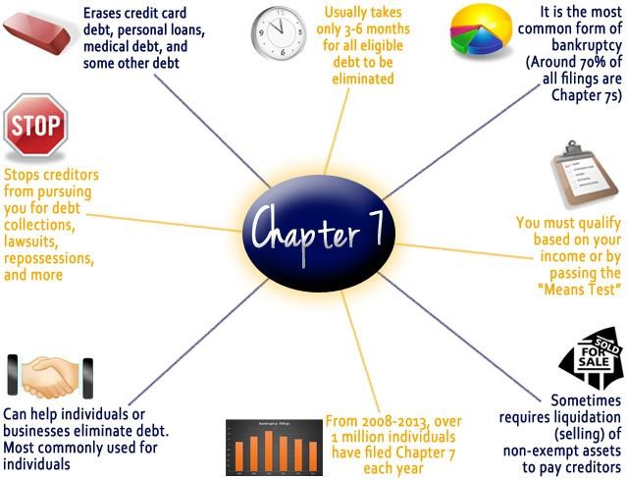
What are the qualifications to file Chapter 7?
To file Chapter 7, there are certain qualification that you must meet. Otherwise, you will have to file Chapter 13 bankruptcy. An experienced attorney can analyze your financial situation to determine if you qualify for Chapter 7.
Here are a few of the qualifications to file Chapter 7
- PRIOR BANKRUPTCY FILINGS: If you have filed bankruptcy previously, you must wait 8 years from your past Chapter 7 or 6 years from your past Chapter 13 before you can file a Chapter 7.
Prior
Bankruptcy
Filings
- INCOME/MEANS TEST: To file Chapter 7 bankruptcy, your income must be equal to or below the median income in your state. If your income is above the median income, you must pass the “means test” to file Chapter 7. The Means Test determines your ability to make repayments in a Chapter 13 repayment plan. Depending on your household size, expenses, total income, and disposable income, you may or may not be able to afford paying a Chapter 13 repayment. If you can make Chapter 13 payments, the court will not allow you to file for Chapter 7, while if you can’t afford a Chapter 13 plan, you may file a Chapter 7.
Income/Means
Test
Credit
Counseling
- CREDIT COUNSELING: Before you can file Chapter 7, you are legally required to take a simple, brief, inexpensive class on credit counseling, where you learn principles of debt and financial management.
How does the Chapter 7 process work?
- DETERMINE ELIGIBILITY: Depending on your situation, you may or may not qualify for Chapter
7. An attorney can help you determine if you should file Chapter 7 or Chapter 13.
- CREDIT COUNSELING: Before you can officially file, you must take a legally required credit counseling class. This class is offered by various non-profit organizations, is inexpensive and short, and teaches you principles about debt management and financial budgeting. You receive a certificate of completion when you finish the course.
- FILE PAPERWORK: If you qualify for Chapter 7, you then fill out and submit the required paperwork to your local court. You must include accurate information about your income, secured and unsecured debts, exempt and non-exempt property, assets, living expenses, and other related financial information. This step is much easier with an attorney, who can guide
you and make sure you complete the paperwork correctly. Your attorney will also make sure that you keep as much property as possible through claiming exemptions.
- AUTOMATIC STAY: Once the court has received and processed your submitted paperwork, they immediately notify all of your creditors of your bankruptcy filing. Your creditors are then legally prevented from pursuing you further for debt collections, evictions, lawsuits, wage garnishments, levies, foreclosures, and other related matters. This is one of the greatest benefits of filing bankruptcy.
- CREDITORS’ MEETING: Soon after your petition is filed, you are required to attend a meeting at the courthouse with your creditors, trustee (the person in charge of overseeing your case), and your attorney (if you hired one). While this meeting is in your local courthouse, it is not a trial. There is no judge present. During this meeting (which usually lasts less than 1 hour), the trustee and creditors review your financial paperwork for accuracy and dispute anything they find to be inaccurate. Your attorney can greatly help you to feel at ease during this part of the process as he or she can advise and help you.
Debt
Discharge
Debtor
Education
Class
Property
Dealt With
Creditors'
Meeting
Automatic
Stay
File
Paperwork
Credit
Counseling
Class
- PROPERTY: Depending on your situation and the type of property that you own, the trustee may require that you give up some property to be sold to pay creditors. But don’t stress too much. Sometimes, the trustee may determine that some property is too difficult to sell and may not require it to be sold. Usually, most of your property is exempt and legally protected from being sold. An attorney can help you determine what property you own is protected by law.
- DEBTOR EDUCATION COURSE: This legally required, inexpensive, short course supplements the credit counseling class that you took prior to filing. You will learn various financial and budgeting principles and receive a certificate upon completion.
- DEBT DISCHARGE: A few months after you file, you and your creditors will receive notice from the court that your eligible debts are now eliminated. You no longer have any legal obligation towards these debts! Some debts may remain, however, such as child support, some tax debt, and student loans.
- FRESH START: While a Chapter 7 bankruptcy can stay on your credit report for up to 10 years, you can begin taking steps to rebuild your credit and start fresh without burdensome debts.
What does it cost to file Chapter 7 bankruptcy?
You may be worried about the cost of filing Chapter 7. Remember that any money you spend filing bankruptcy will save you thousands of dollars in the long run. So while it may seem expensive, filing bankruptcy is a good financial investment on your part.
There are 3 main costs to filing bankruptcy:
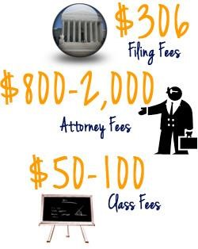
- FILING FEES: This fee is standard in every state and pays for the bankruptcy court to file and administer your case. This fee may sometimes be paid in installments depending on your circumstances.
- ATTORNEY FEES: Usually varies based on the complexity of your situation and where you live. The nationwide average Chapter 7 attorney fee is around $1,500, but it is often less if your case is less complex. An attorney can review your case and help you determine what attorney fees will be and help you find ways to pay for them.
- EDUCATION FEES: You are required by law to take two classes, one before filing and one after filing. There are plenty of inexpensive classes offered by a variety of companies. Usually the credit counseling class costs between $25-50 and the financial management class costs around the same amount as well.
If you are worried about paying for bankruptcy, please discuss payment options with our bankruptcy attorney, who will help you determine how you can pay for bankruptcy with your current income and budget.
How do bankruptcy attorneys help in the Chapter 7 process?
There are many benefits of hiring an attorney to help you file Chapter 7. An experienced bankruptcy attorney makes sure you eliminate as much debt as possible and get the financial fresh start you are looking for.
Specifically, here are some benefits of having an attorney on your side:
- PEACE OF MIND: You don’t have to worry about filing alone, learning bankruptcy law, making legal mistakes, or having your case dismissed. You are more likely to have a successful bankruptcy case and have your debts eliminated with professional help.
- FREE INITIAL CONSULTATION: A bankruptcy attorney can help you understand your options for debt relief and choose the best option to help you get a fresh start.
- AVOID LEGAL MISTAKES: Individuals who try and file alone often make mistakes that can create legal and financial difficulties, while experienced attorneys avoid making these mistakes.
- SUPPORT AND ADVICE: Your attorney will help and advise you through the entire process and become your friend and ally. Your attorney will advise and help you during your required meeting with the trustee and creditors.

Need more help with or information on Chapter 7 bankruptcy?
Call Firebaugh & Andrews for your Free Consultation 734-722-2999
- Call us or fill out a website Free Evaluation form for a Free consultation • Read our other bankruptcy Ebooks

