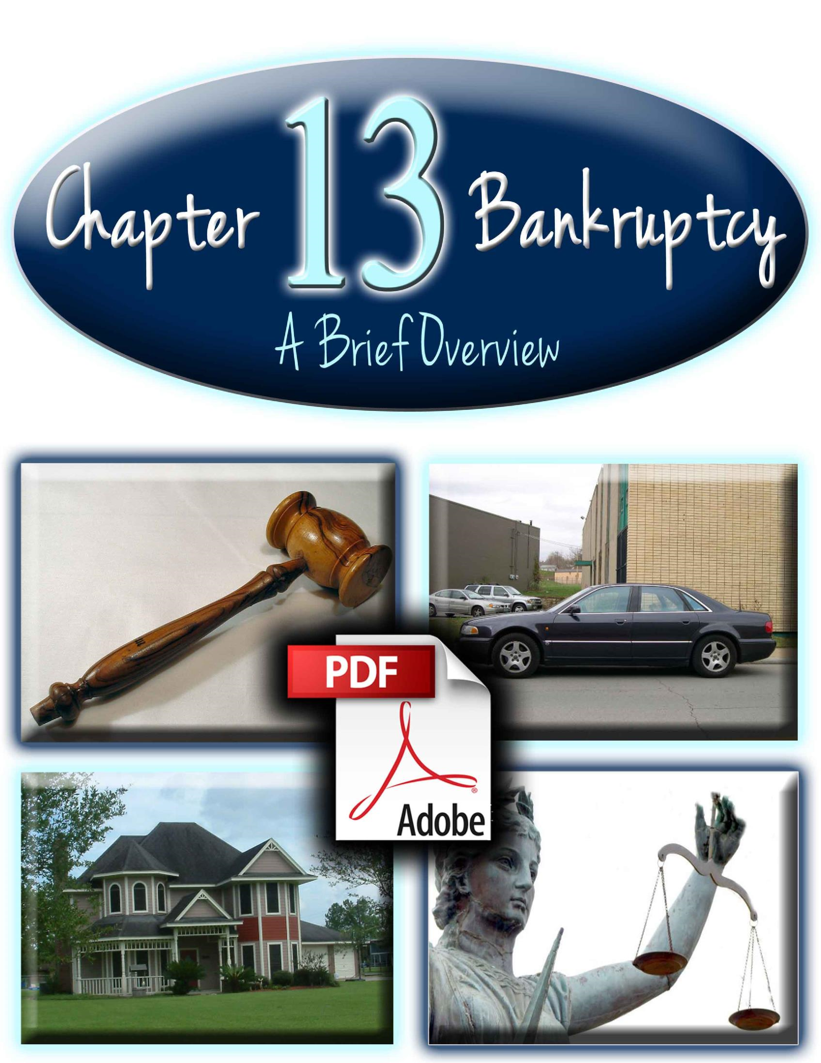

Introduction
This Ebook focuses on Chapter 13 bankruptcy, how it works, and how it helps you eliminate debt and keep your assets (such as your home). We hope you find this information to be helpful.
To discuss Chapter 13 bankruptcy questions please call us for your Free Consultation 734-722-2999
What is Chapter 13 bankruptcy?
Chapter 13 bankruptcy is named after the section of U.S. bankruptcy law dealing with reorganization of debts. Essentially, with Chapter 13, you keep your property (such as home, vehicles, etc) and create a repayment plan that is approved by the court. After successfully keeping up with your debt payments in this plan over 3-5 years, all eligible debts are discharged.
Here are some more important facts about Chapter 13:
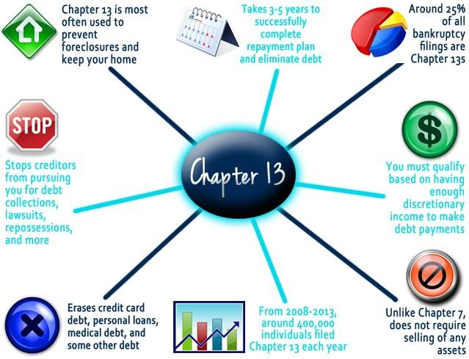

What are the qualifications to file Chapter 13 bankruptcy?
If you do not qualify for Chapter 13, you can still file for Chapter 7. To file Chapter 13, you must meet these qualifications:
- PRIOR FILINGS: You must wait 4 years after filing a prior Chapter 7 bankruptcy or wait 2 years after filing a prior Chapter 13 bankruptcy.
- DISPOSABLE INCOME: Based on the living expenses and payments you have (such as home mortgage and vehicle payments), you may or may not have enough remaining income to be sufficient to successfully fund a debt repayment plan. An attorney can help you calculate
whether or not you have sufficient disposable income for a Chapter 13
plan. If you don’t have sufficient income to fund the plan, you can file for Chapter 7 bankruptcy instead.
Time Between Prior Bankruptcy Filings
Have Sufficient Disposable Income
Debt Amounts Can't Be Too High
Current on Income Tax Payments
Take a Credit Counseling Class
- DEBT AMOUNTS: Your debts cannot be too high. As of 2013, your unsecured debt cannot exceed
$360,475, while your secured debt cannot be
higher than $1,081,400. Most people have far less debt than these amounts, so this usually isn’t an issue in qualifying for Chapter 13. o INCOME TAXES: You must be current on your income tax filings and must show proof that you have filed both state and federal income taxes over the last 4 years. If you are not current on your tax payments, you cannot file a Chapter 13. o CREDIT COUNSELING: You are required to take an inexpensive, helpful class on financial and debt management within 180 days before filing.
How does the Chapter 13 bankruptcy process work?
Chapter 13 bankruptcy takes about 3-5 years to completely eliminate your eligible debts. Here is how it works:
- DETERMINE ELIGIBILITY: You should determine if you are eligible for Chapter 13. If not, you should file a Chapter 7 instead.
- CREDIT COUNSELING: Find a reputable non-profit credit counseling company, take the inexpensive, required class on financial management, and present your certificate of completion along with your bankruptcy paperwork.
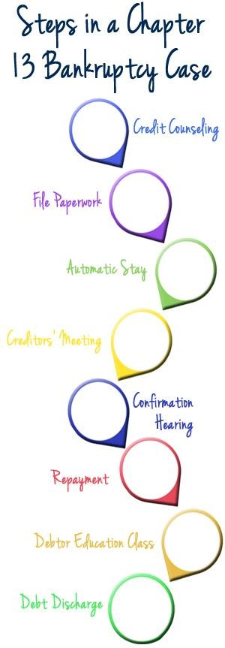
- FILE PAPERWORK: If you qualify for Chapter 13, you then fill out and submit the required paperwork to your local court. You must include accurate information about your income, secured and unsecured debts, exempt and non-exempt property, assets, living expenses, and other related financial information. In addition, you must provide records of your recent state and federal income tax returns. Filling out the required paperwork is much easier with an attorney, who can guide you through and make sure you complete it correctly.
- AUTOMATIC STAY: Once the court has received and processed your submitted paperwork, they immediately notify all of your creditors of your bankruptcy filing. Your creditors are then legally prevented from pursuing you further for debt collections, evictions, lawsuits, wage garnishments, foreclosures, and other related matters.
- CREDITORS’ MEETING: Soon after your
petition is filed, you are required to attend a meeting at the courthouse with your creditors, trustee (the person in charge of overseeing your case), and your attorney (if you hired one). While this meeting is in the courthouse, it is not a trial. There is no judge present. During this meeting (which usually lasts less than 1 hour), the trustee and creditors review your financial paperwork for accuracy and dispute anything they find to be inaccurate. Your attorney can greatly help you to feel at ease during this part of the process as he or she can advise and help you.
- CONFIRMATION HEARING: You create a repayment plan that outlines how much each of your creditors will be paid and how much you will pay each month. This plan is presented before your trustee, a judge, and your creditors in a confirmation hearing in court, where those present may dispute or modify your repayment plan (if necessary). Most often, your plan is approved in this meeting.
- REPAYMENT: Over a 3-5 year period, you make consistent payments to the court. These payments go towards your creditors, trustee, and attorney (if you have an attorney). Your trustee will occasionally review your case to make sure that your plan is going smoothly.
- DEBTOR EDUCATION COURSE: This legally required, inexpensive, short courses supplements the credit counseling class that you took prior to filing. You will learn various financial and budgeting principles and receive a certificate upon completion.
- DEBT DISCHARGE: After you have successfully completed your repayment plan, you and your creditors will receive notice from the court that your eligible debts are now eliminated. You no longer have any legal obligation towards these debts! Some debts may remain, such as child support and student loans.
- FRESH START: While a Chapter 13 bankruptcy can stay on your credit report for 7 years, you can begin taking steps to rebuild your credit and start fresh without burdensome debts.
What does it cost to file Chapter 13 bankruptcy?
If you are worried about the cost of filing Chapter 13, have no fear. Most Chapter 13 costs are spread out as a part of your 3-5 year repayment plan. So usually you don’t have to pay much to start the process.
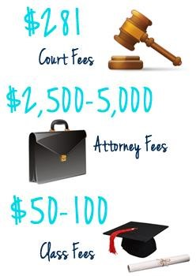
There are 3 main costs to filing Chapter 13 bankruptcy:
- FILING FEES: This fee is standard across all states and goes towards paying for administrative and filing services from the court and the trustee.
- ATTORNEY FEES: Attorney fees are higher for Chapter 13 cases than for Chapter 7 cases due to more extensive work required over a longer period of time. All fees are publicly disclosed and can be modified by the court if they are determined to be unreasonable. These fees vary from area to area, but the court usually sets a benchmark fee standard of what they feel is appropriate to charge. Attorneys that stray too far from that fee will have their fees and case reviewed by the court and often times be forced to lower their fees to be closer to the set standard. Unlike Chapter 7 attorney fees, Chapter 13 attorney fees are often included (at least in part) as part of your repayment plan, meaning you
can spread out your attorney fees over a 3-5 year period. You can call your local court or our bankruptcy attorney to learn about Chapter 13 standard attorney fees in your area.
- EDUCATION FEES: You will need to pay for two classes on credit counseling (before filing) and debtor education (after filing). Both classes teach principles about wise financial management, debt, and budgeting.
If you are worried about paying for bankruptcy, our bankruptcy attorney can give you advice on how to pay for Chapter 13 fees and expenses.
How do bankruptcy attorneys help in the Chapter 13 process?
Unless you are very familiar with bankruptcy law, hiring an attorney to help you file Chapter 13 is most likely your best option. Chapter 13 cases last over several years and can sometimes become complex. Having an attorney by your side through the process will help you feel at ease that your Chapter 13 case will be successful.
Specifically, here are some benefits of having an attorney on your side:
- PROTECTION FROM CREDITOR HARASSMENT: Any creditors that continue to contact you after you’ve filed bankruptcy are doing so illegally. Your attorney can see to it that these creditors are forced to comply with the law and stop harassing you.
- PEACE OF MIND: You don’t have to worry about filing alone, learning bankruptcy law, making legal mistakes, or having your case dismissed. You are more likely to have a successful bankruptcy case and have your debts eliminated with professional help.
- FREE INITIAL CONSULTATION: A bankruptcy attorney can help you understand your options for debt relief and choose the best option to help you get a fresh start.
- AVOID LEGAL MISTAKES: Individuals who try and file alone often make mistakes that can create legal and financial difficulties, while experienced attorneys avoid making these mistakes.
- CONSTANT SUPPORT AND ADVICE: Your attorney will help and advise you through the entire Chapter 13 process and become your friend and ally. Your attorney will advise and help you during your required meeting with the trustee and creditors, as well as through other Chapter 13 meetings in court.
Need more help or information with Chapter 13?
We hope that you have enjoyed this Ebook. For more help learning about Chapter 13 bankruptcy, please:
- Call Firebaugh & Andrews for a Free phone consultation 734-722-2999

